17.41: a) 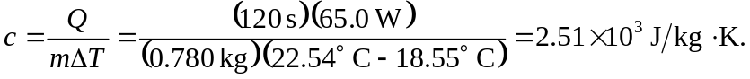

b) An overstimate; the heat  is in reality less than the power times the time interval.

